## **How to fully automate the Covid-19 Data end to end and publish to Tableau Server.**

## **We have already learnt about the HyperAPI in my previous blogs then will not get into the same.**

# Creating and publishing Tableau Hyper extracts with Python

Let’s start writing our script

Import all the required liberaries of Python

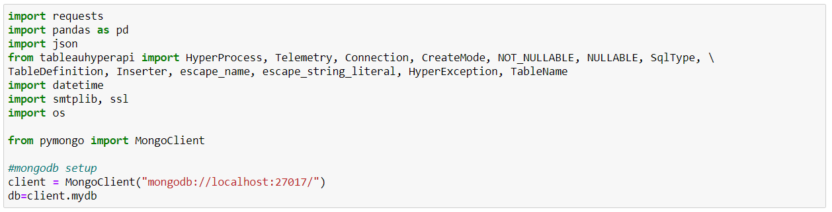

Note: In my demo, I will be storing Covid-19 data into mongo dB as well as in .hyper file so importing all mongo dB related libraries and creating connection between Python and Mongo. You can ignore this part

Setup the target from where we want to bring Covid-19 data. Here I will be using Covid-19 World data.



Left Convert response data into JSON readable format.



Now will convert JSON data into pandas datafram

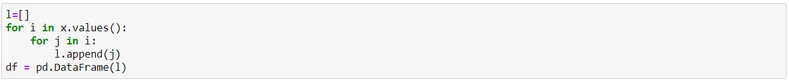

Let’s clean the data first as we may face challenge while inserting into .hyper file with blank and numeric values.

Will also one constant column called **Number of Rows,** which Tableau generates by default while creating extract using Tableau Desktop.

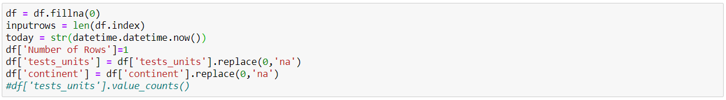

Here I will load data first in mongo db, in your case you can skip this part

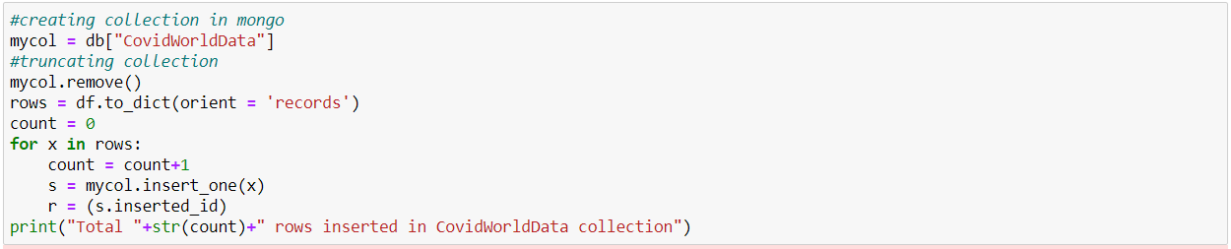

Total 23749 rows inserted in CovidWorldData collection

Here is output of my mongo db

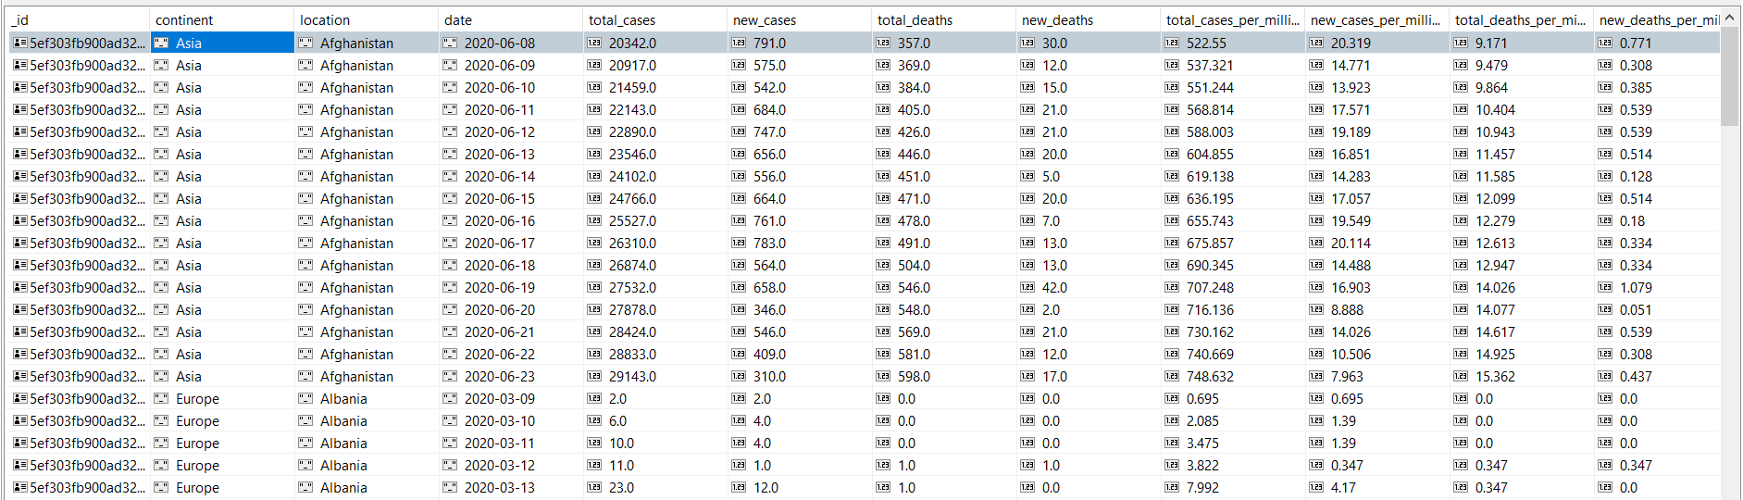

Let’s quickly jump into .hyper process

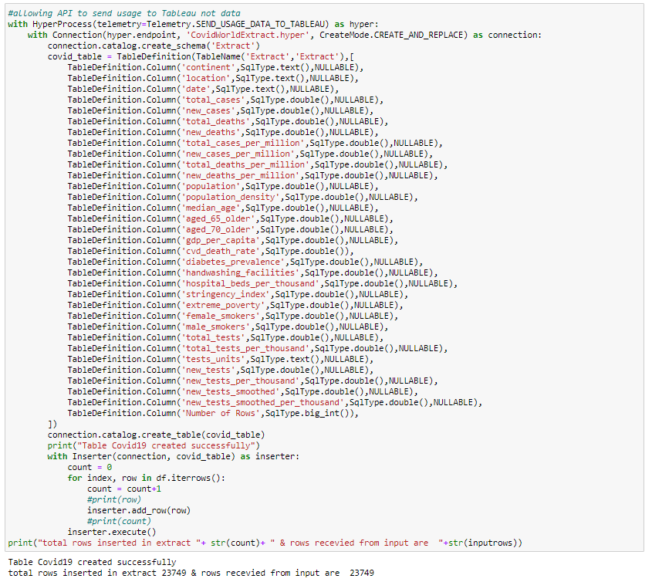

I have kept rows count here intentionally because will use this count validation before publishing the extract

My all confidential details are stored in excel file, so let’s import the file



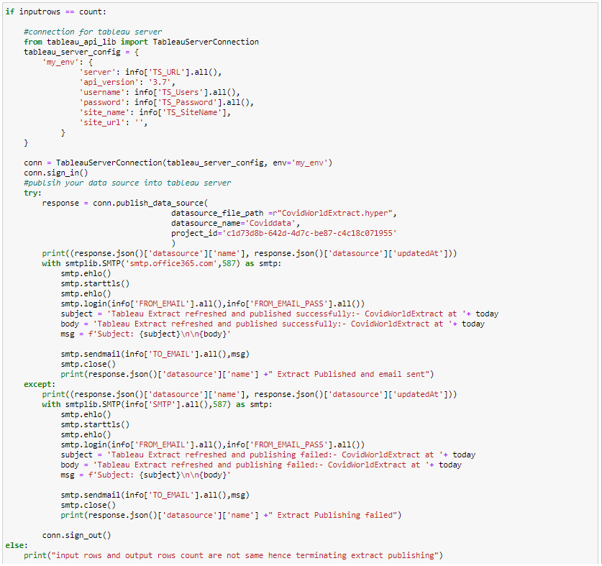

Finally our end to end coding is ready our very next step should be to run the whole code automatically to do the same, will use PowerShell or batch Scripting here.

Here is my Batch file code

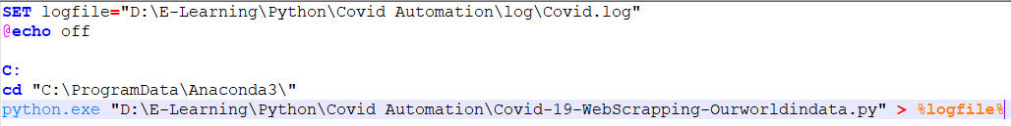

Log file output

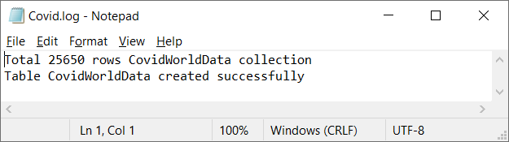

Now our final step is to schedule the job, I will be using Windows Scheduler here

